English |  |  |  | 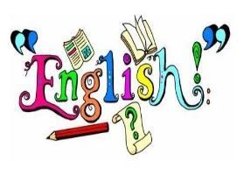
We will begin the year by exploring the traditional tale of The Three Little Pigs. Through this we will focus on writing to entertain. Developing our use of capital letters and full stops and by beginning to use expanded noun phrases, we will describe a variety of setting and characters.  We will then go on to explore the book Troll Swap by Leigh Hodgkinson. Through this we will focus on two writing purposes; writing to entertain, and writing to inform. We will build on our skills from our previous unit and begin to look at coordinating and subordinating conjunctions. We will continue to learn spelling rules and words from the Y1 and Y2 spelling list. |  | In Autumn 2, we will be writing to entertain with a narrative and poetry. We will also be writing to inform with instructions.  We will continue to learn spelling rules and words from the Y1 and Y2 spelling list.
Maths |  |  |  | 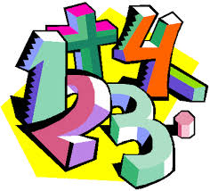
In Autumn 1, we will be focusing on Number: place value, addition and subtraction. |  | In Autumn 2, we will continue our learning of addition and subtraction. We will also visit geometry: properties of 2D and 3D shapes and measurement: length and height.
RE |  |  |  | 
World Faiths  Judaism | Beginnings  God at every beginning | Baptism  Signs and symbols of Baptism | Preparations  Advent
Science |  |  |  | 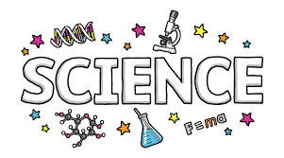
Uses of everyday materials
Throughout the Autumn term, we will identify, group and experiment with every day materials. We will then determine the suitability of certain materials for particular uses.
Topic |  |  |  | 
London’s Calling  In Geography, we will locate and explore London’s landmarks and use compass points and directional language to navigate between them.  In Art, will explore the colours, materials and shapes Andy Goldsworthy uses in his art work. We will examine several of his sculptures and use them as inspiration for their own creations of the London skyline. |  | Fire Fire!  In history, will find out when, where, how and why the Great Fire of London happened, and explore how we know about it through the diary of Samuel Pepys and other sources.  In DT, we will investigate a variety of different vehicles before designing, making and evaluating our own vehicle. We will learn all about wheels, axles and chassis and how they are combined to make the framework of the vehicle.
Computing |  |  |  | 
Computer Systems and Networks – IT Around Us  We will develop our understanding of what information technology (IT) is and will begin to identify examples. We will discuss where we have seen IT in school and beyond, in settings such as shops, hospitals, and libraries. |  | Creating Media – Digital Photography  We will learn to recognise that different devices can be used to capture photographs and will gain experience capturing, editing, and improving photos. Finally, we will use this knowledge to recognise that images they see may not be real.
PSHE |  | 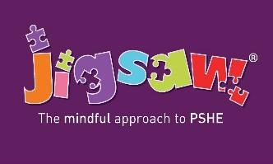
Being Me in My World  We will explore our hopes and worries for the year ahead and how we can make everyone feel welcome. We will also discuss how we can make our school a better place. | Celebrating Differences  We will identify some ways our friends are different from us and discuss why we value the differences we all have.
PE |  | 
In PE, we will play multiskill games, athletics and dance.
Year 2 PE days: St. Elizabeth Tuesday and Friday
St. Joseph Vaz Tuesday and Thursday
Please ensure pupils arrive dressed in their PE kits on these days.
Music |  | 
Britpop and the Sounds of the Nineties  We will be exploring British pop music and famous songs from the 1990s. | The Nutcracker Ballet  We will learn about the concept of ballet and we will use graphic notation to represent the duration of notes.
Educational Visits & Enrichment Opportunities |  | 
In Autumn 1, we will be celebrating London Day as part of our Geography topic. We will be using our new skills in art, geography and English to enrich and further our learning. | In Autumn 2, we will be visiting New Malden Fire Station after learning about the Great Fire of London in history and making fire engines in DT. We will have the chance to use a fireman’s hose and explore a real fire engine.
How you can help at home
- Reading with your child daily. Even if your child is a confident reader, they will benefit from you sharing a book with them and discussing their reading.
- Rehearsing spellings (test is every Monday). Many children learn best when they are being creative. Use coloured pens and pencils to write out words, break out the art supplies and allow your child to use paints, markers, crayons and other colourful creative implements to spell out words. They might also love to use playdough, Lego to build each letter, draw in sand, paint with water or play hide and seek with the words.
- Rehearse number bonds to 10, 20, 50 and 100 as well as the 2, 5 and 10 times tables.
- Support your child to use an analogue clock to tell the time.
- Going to the library and taking out books related to topics we are covering.
- Support your child in phonics: Great websites are www.starfall.com, https://home.oxfordowl.co.uk/reading/learn-to-read-phonics/ and www.phonicsplay.com
- Practise counting at home and writing the numbers correctly.
- Ensure homework is completed and returned by Monday on Google Classroom.
- Encourage active learning such as asking and answering questions; solving problems and exploring interests.
Adults
Teachers: Miss Rodger, Miss Bloomfield and Mrs Howick-Smith
Support staff: Mrs Jude, Mr Chan and Miss Barker (Teach Wimbledon Student)

