English |  |  |  | 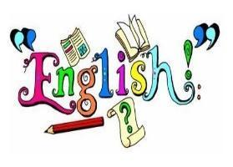
In Autumn 1, our literacy will be based on The Snail and the Whale by Julia Donaldson. The children will focus on two key purposes: writing to entertain and writing to inform. They will develop their use of description through similes and adventurous vocabulary, while also practising grammar skills such as using conjunctions, adverbs, prepositions and paragraphs to organise their ideas. Our final piece of writing will be writing a diary recount inspired by the snail and the whale’s adventures. |  | In Autumn 2, our literacy will be inspired by Cinderella of the Nile by Beverley Naidoo and The Manor House. The children will write to entertain through imaginative narratives and to inform through descriptive recounts. They will develop suspense and atmosphere by using varied sentence types, fronted adverbials, precise vocabulary, and clear paragraphs with accurate punctuation. Later in the term, they will create their own suspenseful stories and descriptive recounts based on the characters and settings from these texts.
Maths |  |  |  | 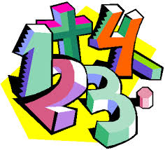
In Autumn 1, we will delve into place value, moving confidently into the hundreds. This will help us understand the crucial role place value plays in all areas of maths. We will also focus on addition and subtraction, revisiting hundreds while tackling more challenging three-digit calculations. |  | In Autumn 2, we will build on our multiplication and division skills. After revisiting the 2-, 5- and 10-times tables, we will take on new challenges by working with the 4- and 8-times tables, developing strategies to multiply and divide with increasing confidence.
RE |  |  |  | 
World Faiths  Judaism | Homes  What would we consider a home to be like? How can we love one another and be a part of God’s family? | Promises  What are the promises we make to God? | Visitors  When do we have visitors?  Which visitor are we all waiting for?
Science |  |  |  | 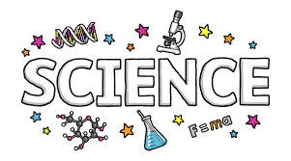
Forces and Magnets  We will compare how things move on different surfaces, explore the differences between forces and magnetic forces. We will observe how magnets work with each other and different materials. |  | Rocks and soils  We will compare and group together different kinds of rocks based on their appearance and simple physical properties. We will describe in simple terms how fossils are formed when things that have lived are trapped within rocks.
Topic |  |  |  | 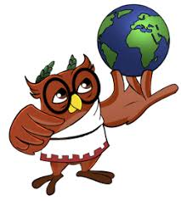
Egypt & The River Nile  In Geography, we will learn to locate the River Nile on a world map and identify the countries it runs through, identify the source and mouth of the river and investigate its main physical and human features. We will explore the significance of the river to the people of Egypt. In DT, we will explore a range of technical vocabulary to describe the features of bridges. We will then test how beams and pillars (or piers) are used to span gaps and distribute weight. |  | Tomb Hunters  We will locate the ancient Egyptians in time and place and learn all about their fascinating lives and culture. We will explore the process of mummification and writing using hieroglyphics.  In art, we will explore Eden Fowell’s Egyptian art style and recreate our own portraits.
Computing |  |  |  | 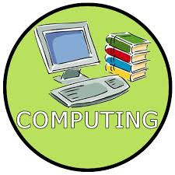
In Computing we will be focusing on how we connect to computers. We will look at what parts make up a digital device and how they help us. We will also be exploring how computers connect to us and how our school networking system works. |  | This half term we will use a range of techniques to create a stop-frame animation using tablets. The children will then apply those skills to create a story-based animation. This unit will conclude with learners adding other types of media to their animation, such as music and text.

PSHE |  | 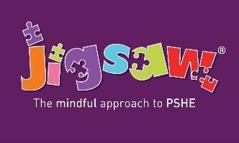
Being Me in My World – this covers a wide range of topics including:  - Welcoming others.  - Being part of the school community and understanding why rules are important.  - Children’s rights and responsibilities.  - Socialising with others.  Facing new challenges. | Celebrating Differences – this focuses on:  - Similarities and differences.  - Understanding my strengths and weaknesses.  - Diversity such as disability, racism, power, friendships and acceptance.  Assessing the level of risks in different situations.
PE |  | 
This term, we will be learning essential skills for Netball, Football and overall fitness.
St Josephine PE – Monday and Wednesday
St Maximillian PE – Monday and Friday
Children should come dressed in their PE kits on these days.
If your child is in a club on a day, which is not one of their allocated PE days, they will still need to bring in their PE kit or a change of clothing in a bag as normal and store in their cloakroom.
Music |  | 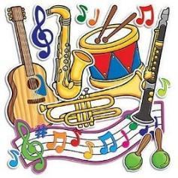
In Autumn 1, we will be exploring music – spot the differences and a variety of different arrangements. | In Autumn 2, we will be exploring Christmas pop songs volume 2 and rhythmic patterns.
Educational Visits & Enrichment Opportunities |  | 
Our young scientists will gear up for an exciting adventure to Sir Joseph Hood Memorial Park, where they’ll dive into a hands-on science investigation all about Forces—learning through exploration, experimentation, and outdoor fun! | Get ready to travel back in time! Our Egyptian Day promises an unforgettable journey into the world of pharaohs, pyramids, and ancient wonders—an enriching experience packed with history, creativity, and hands-on learning!
How you can help at home
- Read with your child daily. Even if your child is a confident reader, they will benefit from you sharing a book with them and discussing their reading.
- Rehearse spellings for their test every Monday. Many children learn better when they’re being creative. They should come up with interesting sentences that include the spelling words and practise writing these out. This will also help them with their handwriting.
- Rehearsing times tables daily (log onto https://ttrockstars.com).
- Go to the library and take out books related to topics we are covering.
- Practise the times tables at home (especially the 2, 5, 10 times tables from year 2)
- Support your children in completing their homework each week.
- Encourage active learning such as asking and answering questions; solving problems and exploring interests.
Adults
Teachers: Mrs Brown and Mr Froud
Support staff: Mr Chan, Mrs Peck, Mrs Sharman, Mrs Wilson-Boyle and Mrs Cooney

