English |  |  |  | 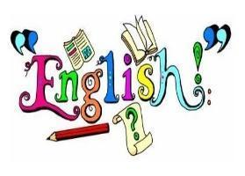
We will begin the year by exploring the book Who Let the Gods Out by Maz Evans. Through this we will focus on two writing purposes; writing to entertain, and writing to inform. Using figurative language techniques such as metaphors and reviewing grammatical features such as relative clauses, we will describe mighty Greek gods/goddesses and fearsome mythical creatures. We will then consider how formality and tone change for the purpose of our writing by writing a first-person recount to inform the reader of a rather peculiar day! |  | In Autumn 2, we will be writing the following genres: suspense narratives and journalistic articles.  In grammar, we will be looking at the passive voice and using bullet points for punctuation.
Maths |  |  |  | 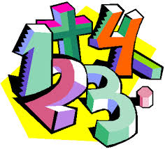
In Autumn 1, we will recap place value; learning to compare, round and order numbers to 10,000,000. We will also be revising written strategies for the four operations up to and including four digits. We will revisit properties of numbers, using and explaining vocabulary such as square, cube and prime numbers. |  | In Autumn 2, we will focus on fractions; equivalents, ordering and comparing, adding and subtracting and multiplying and dividing. Additionally, we will be looking at position and direction.
RE |  |  |  | 
World Faiths  Judaism | Ourselves – Loving  I understand that God loves and cares for his people in difficult times. | Vocation and commitment  I understand the importance of being called. | Expectations  I can demonstrate my understanding of commitment in everyday life.
Science |  |  |  | 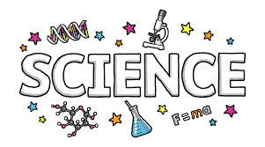
Electricity  We will learn to represent circuits using symbols in a diagram. We will learn about two of the most important scientific inventors in the field of electricity – Alessandro Volta and Nikola Tesla. We will further get the opportunity to develop our understanding of what electricity is and how to control it. |  | Living things and their habitats  We will describe how living things are classified into groups; identify the characteristics of different types of microorganisms; explain the classification of organisms found in our local habitat.
Topic |  |  |  | 
Ancient Greece  We will explore the Ancient Greek timeline; concepts of democracy and how the Greeks influenced modern times. We will use a range of sources to make inferences and deductions about Ancient Greek life.  To enhance our learning about ancient Greece we will be using traditional methods to sculpt terracotta pots and vases during DT lessons. |  | Raging Rivers  We will explore how rivers impact on human life, how their uses have changed throughout history and our impact on them today.  Within art lessons we will look at the influences of street art, exploring how graffiti can polarize opinion; the power of Banksy and create our own designs, using differing painting techniques.
Computing |  |  |  | 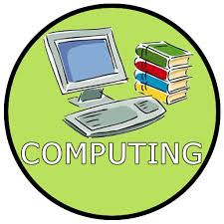
Computing systems and networks - Communication and collaboration  We will explore how data is transferred over the internet and how the internet facilitates online communication and collaboration. We will also learn how to communicate responsibly by considering what should and should not be shared on the internet. |  | Creating media – Web page creation  We will identify what makes a good web page and use this information to design and evaluate our own websites using Google Sites.

PSHE |  | 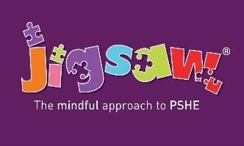
Being me in my world  We will be exploring what it is like to be a global citizen and developing our own learning charter. | Celebrating Differences  We will be exploring what it is like to live with disabilities. We will celebrate difference and develop our communication skills.
PE |  | 
This term in PE, we will be exploring various team games such as tag rugby, football and basketball as well as the invasion game: dodgeball.
Our PE days are:
CLASS – St Andrew Kim – Wednesday and Thursday.
CLASS – St Teresa – Wednesday and Thursday.
Please ensure students come into school dressed in their PE kits on these days.
Music |  | 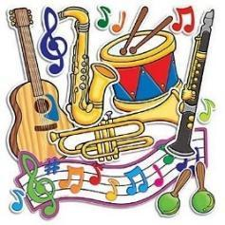
In Autumn 1, we will explore music for film and television.  We will look at also explore the ways in which music can create emotion. | In Autumn 2, we will explore songs from WWII. We will also explore musical processes.
Educational Visits & Enrichment Opportunities |  | 
To support our Greek learning, we will be hosting a Greek day where children will take part in hands on activities, taste some authentic Greek foods in order to enhance our topic understanding. We will also be hosting a MacMillan Coffee Morning. | In Autumn 2 we will be visiting Morden Hall Park as part of our rivers topic. We will also visit Sacred Heart Church as part of our Vocation topic.
How you can help at home
- Reading with your child daily.
- Rehearsing spellings and times tables daily (log onto https://ttrockstars.com ).
- Encourage active learning by playing games at home, where pupils are practising their times tables and division facts, solving problems and asking questions.
- Going to the library and taking out books on our current topics e.g. Ancient Greece.
- Ensure homework is completed and returned via Google Classrooms and home learning journals are brought into school every Monday.
- In preparation for secondary school, please encourage your child to pack their own bag with the appropriate equipment ready for school daily for example, their reading book, diary/planner, home learning journal and kit for clubs.
Adults
Teachers: Mr Connell, Ms Parsons, Mrs Cave, Mrs Bastian
Support staff: Mrs Heridge, Ms Hyatt

