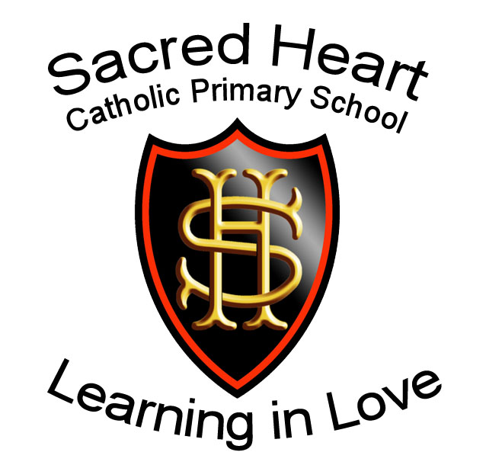

RELIGIOUS EDUCATION POLICY

Mission Statement

Guided by truth, respect and compassion; we share in building upon every individual’s foundation, nurturing a love of learning in preparation for tomorrow’s society, with Jesus at the heart of all we do.

Religious Education Policy

Rationale
Religious Education is the ‘core of the core curriculum’ (Pope St. John Paul II) because ‘At the heart of Catholic education lies the Christian vision of the human person. This vision is expressed and explored in religious education. Therefore, religious education is never simply one subject among many, but the foundation of the entire educational process.’ (Catholic Bishops’ Conference of England and Wales, 2000). Religious Education lies at the heart of the Church’s response to the call of Christ to ‘go out into the world and teach all nations’ (Matthew 28:19).

Religious Education at Sacred Heart aims to promote:
- To follow the Curriculum Directory for Religious Education (RECD and RED), ensuring high standards of teaching and learning in RE.
- To develop knowledge and understanding of the Catholic Church, its traditions, teachings, and mission.
- To provide a strong foundation for a life of faith, rooted in the Gospel values of Faith, Hope, and Love.
- To deepen knowledge and understanding of the Catholic response to the ultimate questions about human life, its origin, and purpose.
- To equip pupils with the skills to examine and reflect on religious belief and practice, encouraging thoughtful and meaningful engagement.
- To foster understanding and awareness of other major world religions, promoting respect and dialogue.
- To embed the Sacred Heart Mission Statement and school motto, Learning in Love, throughout the RE curriculum and wider school life.
- To ensure that RE lessons are faith-filled, engaging, and respectful, where every pupil feels a sense of belonging and is supported to achieve and flourish in their personal faith journey.

How We Meet Our Aims
RE Programme of Study
- EYFS–KS1 follow Lighting the Path (RED) and KS2 follow Come and See (RECD).
- Lessons are planned for progression, depth, and alignment with the Curriculum Directory.
Religious Practice, Liturgy, and Prayer
- Daily collective worship and regular opportunities for prayer, reflection, and liturgy.
- Celebration of Masses, feast days, and the liturgical seasons within school and parish.
- Pupil leadership in worship, with opportunities for pupils to act as prayer leaders and to plan and lead collective worship.
Pastoral Care
- A nurturing environment rooted in Faith, Hope, and Love, reflecting the school motto Learning in Love.
- Behaviour expectations based on Gospel values, ensuring respect and dignity for all.
- Pastoral systems ensure every pupil feels valued, respected, and supporting the whole child
Links with the Parish and the Wider Church
- Close partnership with the parish through shared liturgies, workshops, sacramental preparation, and visits to places of worship.
- Involvement of parish clergy and community in the spiritual life of the school.
- Participation in wider diocesan and deanery initiatives.
Catholic Social Teaching
- Pupils engage in Mission Weeks, charity initiatives, and social action projects inspired by Catholic Social Teaching.
- Opportunities to link learning to CST principles.
Home–School Partnership
- Faith is nurtured through collaborative practices such as the travelling rosary, crib, and cross.
- Parents are encouraged to participate in school liturgies, Masses, and celebrations.
- Strong communication ensures the RE curriculum is supported and celebrated at home.
- Strong support from school during times of sacramental preparation i.e. First Reconciliation and First Holy Communion.
Cross-Curricular Links
- RE themes enriched through literacy, history, art and music
- Exploration of moral, social, cultural, and spiritual development across the curriculum.
- Respect for and understanding of other world religions and traditions including world faith weeks and celebrations across the school year.

Teaching and Learning
- Religious Education is integral to the whole curriculum and permeates all aspects of school life.
- Sacred Heart dedicates 10% of teaching time to RE, in line with the requirements of the Bishops Conference of England and Wales.
- CPD opportunities such as in-school staff training, Diocesan training, CAFOD, and The Well, along with appropriate resourcing and rigorous assessment and monitoring, ensure that RE holds equal status with other core subjects.
- Lessons are planned with clear learning objectives and success criteria, incorporating ‘driver words’ to appropriately challenge pupils.
- Teachers use Rosenshine’s principles, including effective questioning, modelling of skills and knowledge, and checking pupils’ understanding throughout lessons.
- Creative approaches are encouraged, using the ‘Creativity in RE’ guidance, including art, drama, games, debates, and other engaging strategies.

NB: EYFS/KS1 staff were trained in the Lighting the Path (RED) in October 2025 and the scheme was introduced November 2025 (Autumn 2). Once the KS2 scheme has been published, KS2 staff will attend Diocesan training ready to implement in September 2026.

Inclusion and Equal Opportunities in RE
At Sacred Heart, we recognise that children are at different stages of development, and this applies equally to Religious Education. Pupils’ understanding of faith is influenced by their intellectual development, home experience, and cultural background. Children’s engagement and output may also be affected by literacy skills, fine motor development, or social interaction.

The school welcomes children of all faiths and none. Pupils from non-Catholic backgrounds are encouraged to participate fully, while their beliefs are respected and valued, contributing to a rich and diverse learning environment.

Teachers ensure that all pupils can access and engage with RE by:
- Applying Rosenshine’s principles, including modelling, effective questioning, and checking understanding, to support learning for all abilities.
- Using support, challenge and open-ended tasks, providing multiple ways for pupils to succeed and contribute to collaborative learning.
- Incorporating key vocabulary, visual supports, and communication tools such as Communicate in Print (Widget), Google Translate, and other technologies to remove barriers to understanding e.g. Chromebooks
- Providing opportunities for pupils to draw on prior knowledge, personal experience, or cultural background
- Valuing and affirming individual responses, recognising both effort and achievement, and celebrating diverse contributions.

Learning Environment
- All classrooms have a RE focal area, including a liturgical cloth, Bible, Cross, and relevant artefacts.
- Displays feature children’s work, key vocabulary, and visual supports related to current topics, reinforcing learning and accessibility.
- Examples of pupils’ work are showcased throughout the school to celebrate achievement and engagement.
- Prayer spaces are available across the school (including the outside), encouraging pupils to reflect, pray, or engage with faith in a variety of ways, supporting diverse spiritual practices.
- Learning environments are designed to be inclusive, welcoming, and stimulating

Visitors and Enrichment
- Pupils benefit from visits by the Parish Priest, pastoral workers, other faith representatives, and charity representatives (e.g., SVP, CAFOD).
- Parents and carers are invited to share their experiences where appropriate.
- Curriculum-linked workshops take place throughout the year at the Sacred Heart Church, following Mass, led by the faith minister.
- Faith Clubs are offered in KS1 and KS2, led by catechist and faith minister.
- Workshops include Catholic Social Teaching (CST) themes, promoting social justice, service, and charity.
- All activities support inclusion, respect, and engagement, reflecting Sacred Heart values.

Catholic Social Teaching
Links to Catholic Social Teaching principles are explored across RE and the wider curriculum and through prayer and liturgy. Posters with simple prompt images can be seen throughout the school and on displays. Pupils are invited to make links between their learning and worship and the principles. These are also the foundation of the mission weeks. Pupils have participated in CAFOD workshops to deepen their understanding of these principles.

Teaching of Other Religions
Catholic schools should teach about other religions in all phases from Early Years Foundation through to year 6. The Diocesan expectation is that other religions are to be taught for the equivalent of 2 weeks of Religious Education lessons, in each academic year. Pupils learn about other world religions and traditions through world faith weeks:
Autumn – Judaism
Spring – Hinduism
Summer - Islam

We celebrate other festivals such as Moon Festival, Diwali, Holi, Ramadan etc. which are celebrated by many families within our school. We invite those celebrating these festivals to attend school in cultural or national attire and invite them and/or their parents to speak to their classes.

Marking and feedback
Marking follows the Sacred Heart Marking and Feedback Policy.

Assessment and Evidence in RE
Evidence of learning in RE includes:
- RE books, Floor Books (EYFS) and class Ethos Books (KS1/2), capturing shared experiences, insights, and pupil comments.
- Journals allow verbal contributions from pupils who may not record in writing and provide space to show greater depth understanding.
- Children take pride in their RE work, which is marked against lesson objectives
- Teachers may include reflective questions to deepen understanding and promote further engagement.

Teachers continually assess the progress of the children, so that teaching can adjust to pupils’ needs (assessment for learning). We do not attempt to assess the spiritual development of the children, but only their knowledge, skills and attitudes.

In line with the new RED, progress descriptors which sets age related expectations (ARE) for these key areas:
  - Understanding
  - Discern
Respond
EYFS – KS1: Assessment follows the Lighting the Path expectations.
KS2: Come and See units are assessed against these key areas.

Pupils are assessed as working towards, at age related expectations or at greater depth. Assessment for learning questions are asked following these assessments.
Summative judgements are made twice a year following moderation sessions.

The RE leader analyses the data and includes areas of strength and development. This is shared with staff and governors. Actions from data analysis includes CPD, joint planning/teaching and model teaching. Where relevant, links are made to appraisals.

Reporting to parents
The school reports the children’s progress and attainment in the end of year reports.

Leadership of RE
The governors and headteacher are responsible for ensuring that Religious Education has a high profile, and is taught as a core subject.
• As the post of leader of Religious Education is a reserved post, the Education Commission will be invited to exercise advisory rights on behalf of the Archbishop in the appointment process.
• Sacred Heart will appoint a practising Catholic to the post, informing the Education Commission of the name of the postholder: Siobhan Heffron.
• The leader of curriculum Religious Education will have parity in status and remuneration with the leaders of other core curriculum subjects within the school.
• The Religious Education curriculum will be well resourced, both in regard to content and the continuing professional development of those teaching the subject.
• There will be regular and comprehensive monitoring of Religious Education curriculum which clearly demonstrates the impact the subject has on the school.
- Religious Education will be discussed termly at Governors’ meetings, providing support and challenge.
- RE Link Governors will maintain regular communication with the RE lead and visit the school periodically.

RE Leader role:
- Oversee the implementation of the RE policy.
- Lead and support staff through good classroom practice.
- Manage ordering and storage of resources and equipment.
- Stay informed of curriculum updates and communicate them to staff.
- Review and update the RE policy in line with the School Development Plan, national and/or Diocesan changes.
- Monitor progress through work sampling, planning checks, display observation, and lesson observation; report findings to phase leads, the Headteacher, and Governors.
- Support teachers encountering difficulties, disseminate good practice, including supporting non-Catholic staff.

CPD evaluations are reflected upon and used to inform future CPD.

Related policies:
Prayer & Liturgy
Marking and feedback
SEND/Inclusion
RSE

