English |  | 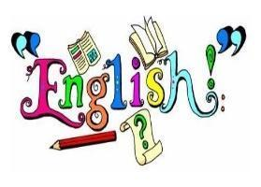
In Autumn 1, we will start our year off by focusing on the story of The Gingerbread man. Using this story, we will be focusing on writing to entertain. We will be learning how to sequence sentences to form a short narrative and practicing saying our sentences aloud before writing them down. We will spend time practicing our pencil grip, finger spaces and capital letters to create a short narrative of our own. | In Autumn 2, we will be revisiting writing to entertain using the cultural story of Little Red and the Very Hungry Lion as well as beginning to practice writing to inform by creating our very own invitations.  We will continue to practice using finger spaces and capital letters and begin to practice full stops for the end of sentences. We will also begin to join words and clauses with ‘and’.
Maths |  | 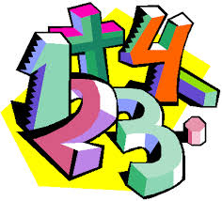
We are starting the school year by building a brilliant foundation in maths! This half-term, we will be diving into lots of fun, hands-on activities to help the children get really comfortable with numbers. We will then explore:  - Place Value within 10 (learning what numbers actually represent, like knowing that '3' means three physical objects).  - Addition and Subtraction within 10 (learning how to add and take away numbers, using concrete objects and pictures to help us). | "In Autumn 2, we will be building on what we've learned by continuing our work on Addition and Subtraction within 10, helping the children feel really secure and confident when adding and taking away.  We will then explore:  - Geometry: Shape (learning to recognize, name, and describe common 2D and 3D shapes, and spotting them in the world around us).  - Place Value within 20 (taking our next exciting step to larger numbers, helping children understand how bigger numbers are made up of tens and ones)
RE |  | 
In RE, our first topic is Creation and Covenant. We will be diving into the beautiful creation story in Genesis to help the children understand the belief that God is the loving creator of our wonderful world. Through storytelling, discussion, and creative activities, we will explore how the world began and introduce the idea of a covenant—which is simply a special, loving promise between God and His people. | In Autumn 2, our RE topic is Prophecy and Promise. As we look forward to Christmas, the children will learn all about the birth of Jesus and be introduced to the Gospel according to Luke). Through this, we will explore how Jesus' birth was the fulfilment of a 'prophecy'—which is a special, exciting promise made by God long ago to send a saviour to the world.
Science |  | 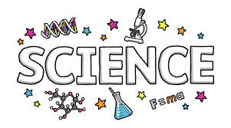
Seasonal Changes  In science we will start our year learning all about the weather and the different seasons! The children will learn to identify different types of weather and the symbols we use to show them (just like on a real weather forecast). We will chat about how the changing seasons affect us—like choosing the right clothes to wear—and discover how different animals adapt to these changes, which is just the clever ways they change their habits or homes to survive as the weather gets colder. | Everyday Materials  In autumn 2, our young researchers will be exploring the world around them by identifying and naming everyday materials, like wood, plastic, metal, and glass. We will have lots of fun investigating and exploring their properties—which is just a scientist's word for what a material is like, such as whether it is bendy or stiff, rough or smooth, or waterproof.
Topic |  | 
Me, Myself and I  We will develop an awareness of the past and use common words and phrases relating to the passing of time e.g., now, next, past, present and future. We will begin to understand chronology; looking at changes within living memory.  In art, we will be inspired by the National Portrait Gallery (Online) to create our own self-portraits. | Where we live (UK)  We will explore the four countries within the UK and identify the capital cities. We will take a trip with Polly to explore the different parts of the UK, learning about different landmarks, weather, culture and languages. We will make comparisons between the different countries of the UK. In DT, we will be designing and making our own Christmas decorations.
Computing |  | 
This term in computing we will be developing an understanding of technology and how it can help us. We will become familiar with the different component of a of a computer by developing their keyboard and mouse skills. We will also start to consider how to use technology responsibly. | In Autumn 2, we will explore the world of digital art and its exciting range of creative tools. We are going to create our own paintings, while getting inspiration from a range of other artists. We will then go on to evaluate painting with, and without, the use of digital devices.

PSHE |  | 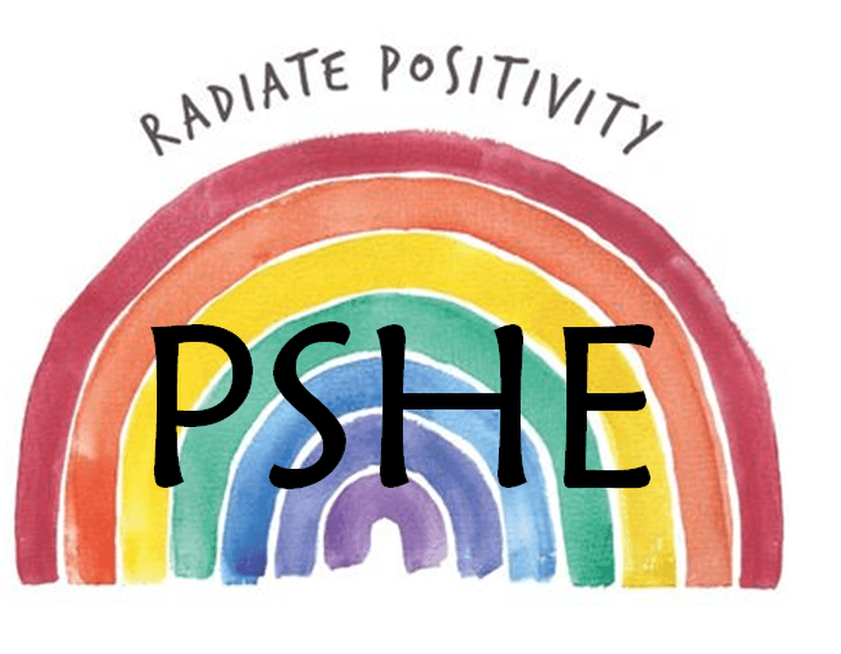
Its My Body  This term we will be exploring how to make healthy and safer choices about their bodies. Children will also learn strategies for looking after themselves and when to seek help from a trusted adult. | Safety First  We are exploring how to keep ourselves safe. We’ll explore staying safe around strangers, both in person and online, learn about The Underwear Rule, and understand the importance of privacy. Children will also learn who they can turn to for help and how they can take responsibility for their own safety.
PE |  | 
This term, we will be learning essential skills for Athletics, Dance, Games and Gym.
Our PE days are:
St Rose – Thursday and Friday
St Oscar Romero – Tuesday and Wednesday
Please ensure students come into school dressed in their PE kits on these days.
Music |  | 
In Music, pupils will learn The Menu Song, exploring how tempo, timbre, texture and rhythm can change the way music sounds. They will also practise singing together and following the conductor’s cues as they prepare their Nativity songs.
Educational Visits & Enrichment Opportunities |  | 
We will be hosting a self- portrait gallery through our corridor. This links to our art topic painting self-portraits | We will be writing invitations to our Christmas nativity then walking to our local post box to send them off.
How you can help at home
- Read with your child daily. Please sign the school diary when your child has read their book, this will enable the adults to know when the book can be changed and if the child is been heard at home. Even if your child is a confident reader, they will benefit from you sharing a book with them and discussing their reading. Ask them questions related to the story e.g.
What does this word mean? Can you think of another word that mean the same? What is the problem in the story? How did they solve the problem? What are your predictions? What is the setting? Can you think of another story that has a similar setting? What was your favourite/least favourite part of the story?
- Rehearse spellings regularly. Many children learn better when they are being creative. Use pens and pencils to write out words, break out the art supplies and allow your child to use paints, markers, crayons and other colourful creative implements to spell out words. They might also love to use playdough, Lego to build each letter, draw in sand, paint with water or play hide and seek with the words. Spellings are tested each Monday.
- Going to the library and taking out books related to topics we are covering.
- It is very important to support your child in phonics, this is a very important skill which supports the children in their reading, writing and spellings. Great websites are www.phonicsplay.com (A wonderful website with online games for your child to play to practise their phonics), https://www.bbc.co.uk/cbeebies/shows/alphablocks (A CBeebies tv programme for children using phonics. Lots of online games on the CBeebies website and app) and www.phonicsbloom.com ( Phonics games focusing on the different phases, tricky words and alien words).
- Practise ensure you spend time practising your number bonds to 20 on NumBots.
- Ensure English Learning Journals are returned every Monday.
Adults
Teachers: Miss Dansie (St Rose) and Miss Edwards (St Oscar Romero)
Support staff: Mrs Peck and Mrs Wilson Boyle

