English – can this be split into the two half terms like the rest of the school? |  | 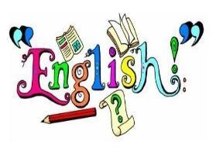
Throughout the Autumn term, we will be focusing on two writing purposes; writing to inform, and writing to entertain.  We will begin the year by exploring the picture book “Katie in London” by James Mayhew. Through this we will focus on writing to inform. Developing our use of capital letters and full stops and by beginning to use expanded noun phrases, we will describe a variety of setting and characters, and use this to create a visitor guide of London. | Our next book is “Dave Pidgeon: Royal Coo” by Swapna Haddow. We will build on our skills from our previous book and begin to look at coordinating and subordinating conjunctions. We will use what we have learnt to write a humorous adventure story of our own.  We will continue to learn spelling rules and words from the Y1 and Y2 spelling list.
Maths |  | 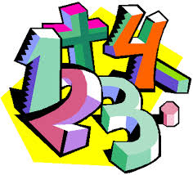
In Autumn 1, we will be focusing on Number: place value, addition and subtraction. | In Autumn 2, we will continue our learning of addition and subtraction. We will also visit geometry: properties of 2D and 3D shapes and measurement: length and height.
RE |  | 
Creation and Covenant  Learning about God’s covenant and what it means to turn towards or away from God. Exploring Baptism and belonging to the Christian family. | Prophecy and Promise  Exploring prophets and how they communicate God’s message. Learning about Advent and Jesus as the promised Messiah.
Science |  | 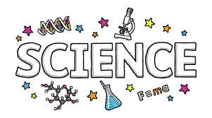
Uses of everyday materials
Throughout the Autumn term, we will identify, group and experiment with every day materials. We will then determine the suitability of certain materials for particular uses.
Topic |  | 
London’s Calling  In Geography, we will locate and explore London’s landmarks and use compass points and directional language to navigate between them.  In Art, will explore the colours, materials and shapes Andy Goldsworthy uses in his art work. We will examine several of his sculptures and use them as inspiration for their own creations of the London skyline. | Fire Fire!  In history, will find out when, where, how and why the Great Fire of London happened, and explore how we know about it through the diary of Samuel Pepys and other sources.  In DT, we will investigate a variety of different vehicles before designing, making and evaluating our own vehicle. We will learn all about wheels, axles and chassis and how they are combined to make the framework of the vehicle.
Computing |  | 
Computer Systems and Networks – IT Around Us  We will develop our understanding of what information technology (IT) is and will begin to identify examples. We will discuss where we have seen IT in school and beyond, in settings such as shops, hospitals, and libraries. | Creating Media – Digital Photography  We will learn to recognise that different devices can be used to capture photographs and will gain experience capturing, editing, and improving photos. Finally, we will use this knowledge to recognise that images they see may not be real.
PSHE – Please add more detail here! |  | 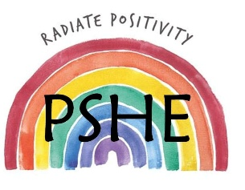
This term, we are exploring the unit VIPs (Very Important Persons) as part of our PSHE and Citizenship curriculum.  Through this topic, children will learn about the special people in their lives—including family and friends—and celebrate what makes each family group unique. They will discover how positive relationships help us feel safe, loved, happy, and cared for. | Next term, we are exploring the unit One World.  Children will embark on a journey around the globe to discover how communities live, while exploring the shared values of love, care, and respect that connect us all. They will learn to appreciate diversity and understand how different environments and cultures shape daily life.
PE |  | 
In PE, we will play multiskill games, athletics and dance.
Year 2 will have PE as a year group on Monday and Tuesday.
Please ensure pupils arrive dressed in their PE kits on these days.
Music |  | 
In Music, pupils will learn Tony Chestnut, exploring the beat, rhythm and melody through singing and echoing musical phrases. They will then practise their Nativity songs, learning how to sing together and follow the conductor’s cues.

Educational Visits & Enrichment Opportunities |  | 
In Autumn 1, we will be celebrating London Day as part of our Geography topic. We will be using our new skills in art, Geography and English to enrich and further our learning. | In Autumn 2, we will be visiting New Malden Fire Station after learning about the Great Fire of London in history and making fire engines in DT. We will have the chance to use a fireman’s hose and explore a real fire engine.
How you can help at home
- Reading with your child daily. Even if your child is a confident reader, they will benefit from you sharing a book with them and discussing their reading.
- Rehearsing spellings (test is every Monday). Many children learn best when they are being creative. Use coloured pens and pencils to write out words, break out the art supplies and allow your child to use paints, markers, crayons and other colourful creative implements to spell out words. They might also love to use playdough, Lego to build each letter, draw in sand, paint with water or play hide and seek with the words.
- Rehearse number bonds to 10, 20, 50 and 100 as well as the 2, 5 and 10 times tables.
- Support your child to use an analogue clock to tell the time.
- Going to the library and taking out books related to topics we are covering.
- Support your child in phonics: Great websites are www.starfall.com, https://home.oxfordowl.co.uk/reading/learn-to-read-phonics/ and www.phonicsplay.com
- Practise counting at home and writing the numbers correctly.
- Encourage active learning such as asking and answering questions; solving problems and exploring interests.
Adults
Teachers: Miss Mason, Miss Bloomfield and Miss Nobrega
Support staff: Mr Chan and Miss Cooney

