English |  | 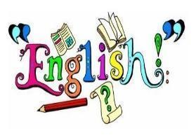
In Autumn 1, our literacy will be based on The Egyptian Cinderella by Shirley Climo and  The Ancient Egypt Sleepover by Stephen Davies. The children will focus on two key purposes: writing to entertain and writing to inform. They will develop their use of description through similes and adventurous vocabulary, while also practising grammar skills such as using conjunctions, adverbs, prepositions and paragraphs to organise their ideas. | In Autumn 2, our literacy will be based on George’s Marvellous Medicine by Roald Dahl and The Ancient Egypt Sleepover by Stephen Davies. The children will focus on two key purposes: writing to persuade and writing to entertain. They will develop persuasive language through opinions, reasons, emotive vocabulary and rhetorical questions. Diary writing will encourage them to write in role, explore thoughts and feelings, and use descriptive vocabulary.
Maths |  | 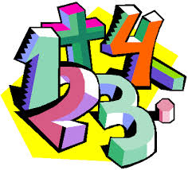
In Autumn 1, we will develop our understanding of place value and work with numbers up to the hundreds. We will explore how the value of each digit helps us to understand and work with numbers. We will also focus on addition and subtraction, revisiting hundreds while tackling more challenging three-digit calculations. | In Autumn 2, we will build on our multiplication and division skills. After revisiting the 2, 5 and 10 times tables, we will take on new challenges by working with the 4 and 8 times tables. Developing strategies to multiply and divide with increasing confidence.
RE |  | 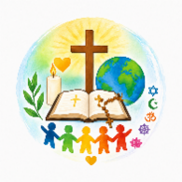
Creation and Covenant  Exploring God as Creator and learning about human dignity and equality. Understanding  why Catholics gather for Mass and care for creation | Prophecy and Promise  Learning how Christians believe Jesus fulfils God’s promises. Exploring Advent and preparing for the coming of Christ.
Science |  | 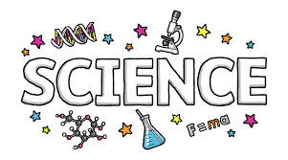
Forces and Magnets  In Science, we will explore how forces affect the way things move on different surfaces, as well as investigating magnets and how they interact with each other and different materials. A visit to our local park will give us the opportunity to spot and explore forces in action. | Rocks and soils  In Science, we will investigate different types of rocks, comparing and grouping them by their appearance and properties. The children will also explore the fascinating process of fossil formation and discover how the remains of living things can become preserved in rocks.
Topic |  | 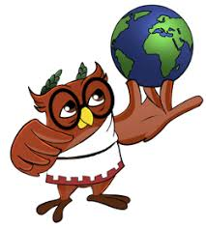
Egypt & The River Nile  In Geography, we will explore the River Nile, locating it on a map and identifying its source, mouth and the countries it flows through. We will learn about its physical and human features and discover why the Nile is so important to the people of Egypt. In DT, we will learn about the different features of bridges and the vocabulary used to describe them. We will then design and build our own truss bridges using lollipop sticks. | Tomb Hunters  In History, we will explore the fascinating world of Ancient Egypt, learning about their lives, mummification and hieroglyphics. A visit to the British Museum will bring our learning to life as we discover Ancient Egyptian artefacts. In Art, Year 3 will explore Ancient Egyptian art and create their own papyrus scrolls, inspired by the skills and techniques used by the Ancient Egyptians.
Computing |  | 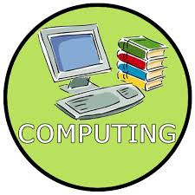
In Computing we will be focusing on how we connect to computers. We will look at what parts make up a digital device and how they help us. We will also be exploring how computers connect to us and how our school networking system works. | This half term we will use a range of techniques to create a stop-frame animation using tablets. The children will then apply those skills to create a story-based animation. This unit will conclude with learners adding other types of media to their animation, such as music and text.

PSHE |  | 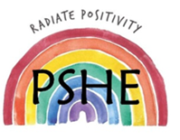
Health and Wellbeing: It’s my Body – this covers a wide range of topics including:  - How to keep my body healthy  - Why it is important to get enough sleep  - The importance of hygiene  - How to take medicine safely  - How to choose healthy habits | Health and Wellbeing : Safety First – this focuses on:  - Making good choices to stay safe and healthy  - Identifying a risky situation and acting responsibly  - To stay safe when out and about.
PE |  | 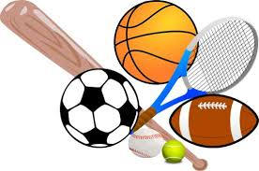
This term, we will learn essential skills for Netball, Football, and overall fitness.
St Josephine PE – Wednesday and Thursday
St Maximillian PE – Monday and Wednesday
Children should come dressed in their PE kits on these days.
If your child is in a club on a day which is not one of their allocated PE days, they will still need to bring in their PE kit or a change of clothing in a bag as normal and store in their cloakroom.
Music |  | 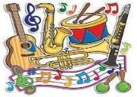
In music, pupils will explore the classical work Carnival of the Animals, listening to how different instruments, pitches and rhythms bring the animals to life. They will develop their singing through simple harmonies, then practise singing in rounds as they prepare for the Christmas Carol Service.
How you can help at home
- Please try to read with your child every day and talk about what they have read. Asking questions about the characters, events and their ideas will help develop their understanding and comprehension. Please record what they have read in their reading record and add a short comment about how they found the reading.
- Rehearse spellings for the Monday test. Children can use their spelling words in creative, interesting ways (see Google Drive), helping them remember the words while also practicing their handwriting and presentation.
- Visit the library and take out books related to topics we are covering.
- Times Tables Rock Stars - Children can use Times Tables Rock Stars to practise their times tables in a fun and engaging way. Regular practice will help them build confidence and improve their speed and accuracy.
- Encourage active learning such as asking and answering questions; solving problems and exploring interests.
Adults
Teachers: Mrs Brown and Mr Froud
Support staff: Mrs Harris and Mrs Cooney

