English |  | 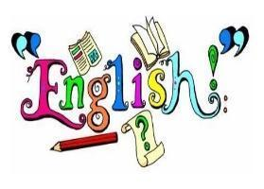
In Autumn 1, Year 4 pupils will develop their fiction and non-fiction writing skills through a range of engaging texts and topics. In descriptive writing, pupils will learn how to create vivid characters and settings by selecting precise vocabulary and using expanded noun phrases, figurative language. Pupils will also develop their use of varied sentence structures and fronted adverbials to add detail and cohesion to their writing.  Alongside this, pupils will develop their non-fiction writing skills by researching and presenting information in the form of non-chronological reports. They will learn how to organise their writing effectively using paragraphs, headings and subheadings, as well as using clear and precise vocabulary. | In Autumn 2, we will use the book The Firework Maker’s Daughter as a stimulus to write a range of different types of poetry, including cinquain, shape and free verse poetry. Pupils will explore how poets use carefully chosen vocabulary, imagery and figurative language to create vivid images.  Later in the term, we will explore Alice in Wonderland by Lewis Carroll. We will use this imaginative text as inspiration to write clear and engaging sets of instructions based on how to escape Wonderland. Pupils will develop their use of imperative verbs, adverbials and precise vocabulary, while learning how to organise their writing effectively.
Maths |  | 
In Autumn 1, we will be recap  Number: place value, addition and subtraction.  We will also be learning and revising our times tables. | In Autumn 2, we will explore Measurement: length and perimeter. We will also be looking at problem solving using mental and written multiplication and division methods.
RE |  | 
Creation and Covenant  Exploring God’s covenant with Abraham and the meaning of faith. Learning how faith, hope and love draw Christians closer  to God. | Prophecy and Promise  Learning about prophets and their role in preparing people for the Messiah. Exploring Advent as preparation for Christ’s coming.
Science |  | 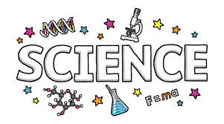
Sound  We will discover that vibrations from sounds travel through a medium to the ear, by exploring how high and low sounds are created. | States of Matter  We will develop our understanding of states of matter, including how materials can change from one state to another, through a large range of simple practical enquiries.
Topic |  | 
Roman Britain  We will investigate the Roman Empire, the Roman invasions and British resistance. We will also look at the impact that the Romans still have in the UK today.  In DT, we will research, design and make our own Roman style sandals. | Volcanoes  We will describe and understand the formation and eruption of volcanoes. We will use atlases, globes, computer mapping to locate volcanoes across the World.  In art, we will take inspiration from Georgia O’Keefe’s ‘Melting Volcano’ to create our own volcanic art.
Computing |  | 
Computing systems and networks – The Internet  Students will deepen their knowledge of networks and the internet's structure and security. They'll distinguish the World Wide Web from the broader internet and understand content ownership and credibility. The aim is to cultivate informed digital citizens. | Creating media - Audio production  Students will study digital audio, understanding devices such as microphones and headphones. They'll learn about audio ownership and its legalities. Through hands-on tasks, they'll develop podcasts, blending technical skills with ethical insights.

PSHE |  | 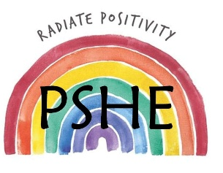
Working in a Team  This unit is inspired by the idea that if a class team works well together, it has a positive impact on all of its members and what they they can achieve. It aims to enable the children to identify the impact their actions have on the team they are working in. | Health and Wellbeing - Think Positive  This unit is designed to build on what the children have already learnt about feelings, both comfortable and uncomfortable and how our attitude towards life can affect our mental health.
PE |  | 
This term, we will be improving our skills in football, tag rugby, hockey and dodgeball.
PE days will take place on Tuesday and Thursday (St. Peter) and Monday and Thursday (St. Clare).
Please make sure to arrive at school in your PE kits on these days.
Music |  | 
In music, pupils will learn This Little Light of Mine, practising its melody and rhythm while building confidence singing together and keeping a steady pulse. They will then develop their singing technique, focusing on clear words, breathing and singing as a group as they prepare for the Christmas Carol Service.
Educational Visits & Enrichment Opportunities |  | 
In Autumn 1, we will be visiting West Barnes Library, where the children will have the chance to explore a wide range of books and develop their love of reading. We will also be enjoying an exciting Roman Day, where pupils will take part in hands-on activities to experience what life was like in Roman times. | In Autumn 2, as part of our commitment to living out Catholic Social Teaching, we are hoping to visit the Dementia Club at Sacred Heart Church/Care Home (to be confirmed). This will give pupils a valuable opportunity to show compassion, connect with others, and serve the local community in a meaningful way.
How you can help at home
- Reading with your child daily. Even if your child is a confident reader, they will benefit from you sharing a book with them and discussing their reading.
- Rehearsing spellings and times tables daily e.g. log on to Times Table Rockstars. https://ttrockstars.com .
- Going to the library and taking out books about the Romans and Volcanoes.
- Support your child to use an analogue clock to tell the time.
- Ensure homework is completed and returned via Google Classrooms and, where necessary in the homework book.
- Encourage active learning such as asking and answering questions; solving problems and exploring interests.
Adults
Teachers: Mr Connell (St. Peter) / Ms Barker (St. Clare)
Support staff: Mrs Hyatt, Mr Chan, Mrs Sharman.

