English |  | 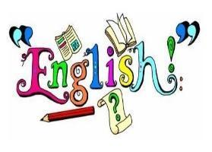
We will begin the year by exploring Viking Boy by Tony Bradman. Through this text, we will develop our understanding of historical narrative writing and write a first-person narrative from the viewpoint of a Viking child. We will explore how to bring a historical setting to life through vivid description, figurative language and carefully chosen vocabulary. We will also develop our use of varied and complex sentence structures to describe characters, settings and experiences from a Viking child’s perspective. | We will continue to develop our writing through a range of genres linked to inspirational women and space exploration. We will write a non-chronological report titled Life as a Viking Child and explore diary writing through A Galaxy of Her Own, writing from the perspective of astronaut Helen Sharman. We will also study speech writing, using the story of Mary Jackson to consider how language can be used to inform, inspire and persuade an audience. Across these units, we will focus on organising our ideas clearly, selecting ambitious vocabulary and adapting our writing for different purposes and audiences.
Maths |  | 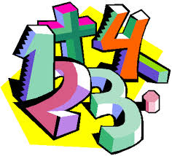
In Autumn 1, we will be recapping Number: place value, addition and subtraction and multiplication and division. | In Autumn 2, we will continue multiplication and division, and begin our fractions learning.
RE |  | 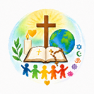
Creation and Covenant  Exploring God’s covenants and the Ten Commandments. Learning how commandments and virtues guide Christians in loving God and others. | Prophecy and Promise  Learning about David and God’s covenant with him. Exploring how Christians believe Jesus fulfils God’s  promises.
Science |  | 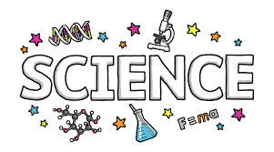
Properties & Changes in Materials  We will build a more systematic understanding of materials by exploring and comparing the properties of a broad range of materials. We will experiment with reversible changes, including, evaporating, filtering, sieving, melting and dissolving. We will also explore changes that are difficult to reverse, for example, burning. | Earth & Space  We will be introduced to a model of the Sun and Earth that enables them to explain day and night. We will learn that the Sun is a star at the centre of our solar system and that it has eight planets. We will understand that a moon is a celestial body that orbits a planet (Earth has one moon; Jupiter has four large moons and numerous smaller ones).
Topic |  | 
Anglo-Saxons & Vikings  In history, we will learn about the Viking and Anglo-Saxon struggle for the Kingdom of England to the time of Edward the Confessor.  In DT, we will explore the design of Viking Longships and use our understanding of materials to create our own replicas. | Extreme Earth  In geography, will explore and describe key aspects of physical geography specifically volcanoes and earthquakes. In art, we will take inspiration from Van Gogh’s ‘Starry Night’ to make our own interpretations.
Computing |  | 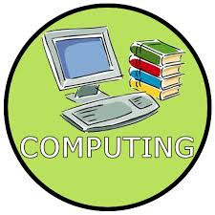
Sharing information  This term we will be looking at computing systems and how web searching is used. | Video editing  Students will learn how to edit videos using specific software.

PSHE |  | 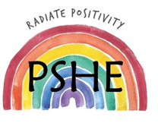
It’s My Body  In PSHE, we will explore how to look after our physical and mental health. Children will learn about healthy choices, exercise, sleep, body image and how to seek help or support when needed. | Aiming High  In PSHE, we will explore Aiming High, focusing on achievements, aspirations and future opportunities. Children will consider their strengths, how to overcome challenges and the skills and attitudes needed to achieve their goals.
PE |  | 
This term in PE we will be working on becoming Sports leaders with a dedicated program and working on improving our football skills.
In Autumn 2, we will be improving our fitness and playing rugby.
PE days will be Tuesday and Friday for St Paul class and for St Kateri class, Monday and Friday. Please ensure pupils arrive dressed in their PE kits on these days.

Music |  | 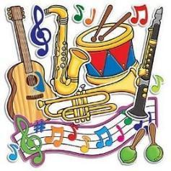
In Music, pupils will explore the sea shanty What Shall We Do with the Drunken Sailor?, learning about beat, rhythm, chords, bass and dot notation. They will also develop their singing technique as they prepare for the Christmas Carol Service.
Educational Visits & Enrichment Opportunities |  | 
In Autumn 1 we will be visiting Sacred Heart church as part of our Life Choices topic. We will also be enjoying a Viking workshop, where pupils will take part in hands-on activities to experience what life was like in the Viking era. | In Autumn 2 we will arrange for a spaced themed workshop.
How you can help at home
- Reading with your child daily.
- Rehearsing spellings and times tables daily (log onto https://ttrockstars.com).
- Encourage active learning by playing games at home, where pupils are practising their times tables and division facts, solving problems and asking questions.
- Going to the library and taking out books on our current topics e.g. Anglo Saxons
Adults
Teachers: Miss Simmonds, Mr Bush
Support staff: Miss Carella, Miss Nunn and Mrs Cichon

