English |  | 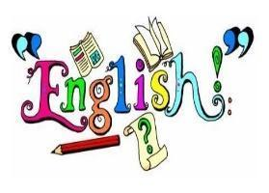
We will begin our year by exploring The Orchard Book of Greek Myths, focusing on the climax of Daedalus and Icarus. We will develop our vocabulary, grammar and storytelling skills before writing a three-paragraph myth retelling in the third person and past tense to create tension, suspense and tragedy.  We will then begin to explore the humour and chaos of Who Let the Gods Out? by Maz Evans before writing a diary entry from Elliot’s perspective. We will focus on one significant moment, using first person and past tense to convey his thoughts and describe mighty Greek gods/goddesses. | In Autumn 2, we will delve into Floodland by Marcus Sedgwick, developing our understanding of portraying viewpoint and tension. We will write a first-person narrative scene set around one significant moment, using dialogue to move the action forward. We will further develop our use of character voice, descriptive setting descriptions and rich vocabulary while using accurate speech punctuation and a range of grammatical features such as parenthesis and relative clauses to make our writing engaging.
Maths |  | 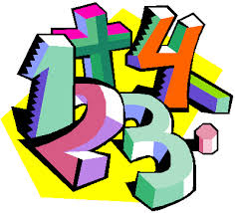
In Autumn 1, we will recap place value; learning to compare, round and order numbers to 10,000,000. We will also be revising written strategies for the four operations up to and including four digits. We will revisit properties of numbers, using and explaining vocabulary such as square, cube and prime numbers. | In Autumn 2, we will focus on fractions; equivalents, ordering and comparing, adding and subtracting and multiplying and dividing. Additionally, we will be looking at position and direction.
RE |  | 
Creation and Covenant  We will be exploring Christian beliefs  about Creation, the Fall, sin and  salvation. Understanding how  faith and scientific explanations  of the universe can work  together. | Prophecy and Promise  We will be exploring the importance of  women in salvation history  and Mary’s response to  God. Learning how Mary  fulfils God’s promises.
Science |  | 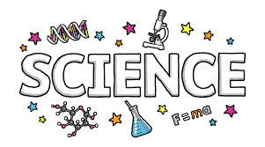
Electricity  We will learn to represent circuits using symbols in a diagram. We will learn about two of the most important scientific inventors in the field of electricity – Alessandro Volta and Nikola Tesla. We will further get the opportunity to develop our understanding of what electricity is and how to control it. | Living things and their habitats  We will describe how living things are classified into groups; identify the characteristics of different types of microorganisms; explain the classification of organisms found in our local habitat.
Topic |  | 
Ancient Greece  We will explore the Ancient Greek timeline; concepts of democracy and how the Greeks influenced modern times. We will use a range of sources to make inferences and deductions about Ancient Greek life.  To enhance our learning about ancient Greece we will be using traditional methods to sculpt terracotta pots and vases during DT lessons. | Raging Rivers  We will explore how rivers impact on human life, how their uses have changed throughout history and our impact on them today.  Within art lessons we will look at the influences of street art, exploring how graffiti can polarize opinion; the power of Banksy and create our own designs, using differing painting techniques.
Computing |  | 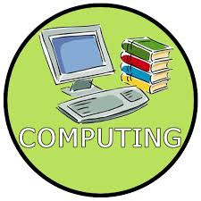
Computing systems and networks - Communication and collaboration  We will explore how data is transferred over the internet and how the internet facilitates online communication and collaboration. We will also learn how to communicate responsibly by considering what should and should not be shared on the internet. | Creating media – Web page creation  We will identify what makes a good web page and use this information to design and evaluate our own websites using Google Sites.

PSHE |  | 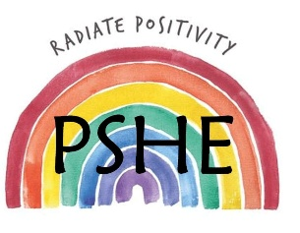
Think Positive  We will explore how our thoughts, feelings and emotions are connected, how to make positive choices, and how mindfulness and a growth mindset can help us navigate life’s challenges. | One World  We will explore what it means to be responsible global citizens. We will learn about sustainability, climate change and biodiversity, and consider how our everyday choices can help protect our planet and make the world a better place.
PE |  | 
This term in PE, we will be exploring various team games such as tag rugby, football and basketball as well as the invasion game: dodgeball.
Our PE days are:
CLASS – St Andrew Kim – Monday and Friday.
CLASS – St Teresa – Wednesday and Friday.
Please ensure students come into school dressed in their PE kits on these days.
Music |  | 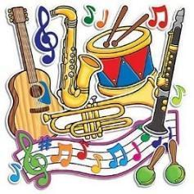
Pupils will explore Shadows by comparing musical genres. They will then listen to March of the Women as part of their Composing for Protest unit and create their own compositions. | Pupils will develop their singing technique as they prepare for the Christmas Carol Service.
Educational Visits & Enrichment Opportunities |  | 
To support our Greek learning, we will be hosting a Greek day where children will take part in hands on activities, taste some authentic Greek foods in order to enhance our topic understanding. We will also be hosting a MacMillan Coffee Morning. | In Autumn 2 we will be visiting Morden Hall Park as part of our rivers topic. We will also visit Sacred Heart Church as part of our RE learning.
How you can help at home
- Reading with your child daily.
- Rehearsing spellings and times tables daily (log onto https://ttrockstars.com ).
- Encourage active learning by playing games at home, where pupils are practising their times tables and division facts, solving problems and asking questions.
- Going to the library and taking out books on our current topics e.g. Ancient Greece.
- CGP book homework pages will be posted on Google Classroom for you to access and complete as an addition.
- In preparation for secondary school, please encourage your child to pack their own bag with the appropriate equipment ready for school daily for example, their reading book, diary/planner, home learning journal and kit for clubs.
Adults
Teachers: Miss Rodger and Miss Haslam
Support staff: Mrs Heridge and Mrs Hyatt

