Area |  | Autumn 1  Marvellous Me! | Autumn 2  Amazing Adventures
Communication & Language | 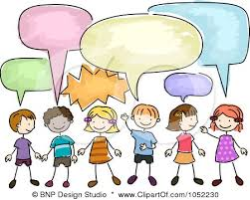 | Naming body parts, family members and basic emotions. Enjoying songs, rhymes and stories about ourselves and our families. | Joining in with repeated words and actions in familiar stories. Learning new words linked to journeys, places and movement.
Physical & Motor Skills |  | Developing fine-motor skills through dough, threading and mark-making. | Developing balance and coordination through crawling, climbing, jumping and moving over, under and through obstacles.
Social & Emotional Development | 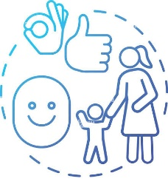 | Settling into nursery routines, building relationships and developing a sense of belonging. Beginning to recognise and express simple emotions. Building independence with simple self-care routines. | Building confidence through new experiences. Learning to explore safely, take turns and play alongside others.
Enrichment Opportunities |  | Children will take part in a ‘This Is Me’ celebration day, exploring baby photographs, creating self-portraits and sharing their favourite songs, toys and family traditions. | Inspired by We’re Going on a Bear Hunt by Michael Rosen, children will enjoy an on-site camping adventure, exploring a sensory bear-hunt trail before gathering in a pretend tent for stories, songs and a picnic.
How to help at home | - Share stories, songs and nursery rhymes every day.  - Talk to your child about everyday routines and experiences.  - Encourage your child to communicate their needs and make simple choices.  - Support independent eating, drinking from an open cup and using cutlery.  - Encourage your child to help with dressing and putting on their coat and shoes.  - Support toilet training when your child shows they are ready.  - Establish consistent routines for mealtimes, bath time and bedtime.  - Encourage your child to tidy away their toys after playing.
Adults
Nursery Manager: Mrs Minns
Nursery Assistants: Miss Turner, Mrs Mirna

